**What Happened Part 1 (2013)**

**The Invitation**

[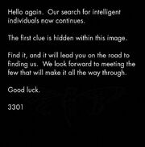](https://vignette.wikia.nocookie.net/uncovering-cicada/images/6/67/1357366592898.jpg/revision/latest?cb=20130105172755)

The original image uploaded on January 4th.

It had been exactly 366 days since the 2012 Cicada puzzle began. Nothing had happened in 11 months.

Until the 5th of January 2013, when a second image was posted to /x/ and /b/ imageboards on 4chan.  There were three threads where 3301 posted [232.jpg](http://static3.wikia.nocookie.net/__cb20130105172757/uncovering-cicada/images/6/67/1357366592898.jpg) on 4chan, two times on /b/ 23 hours apart([1](http://pastebin.com/DDegZqLv),[2](http://pastebin.com/FfKH6ACw)) and once on [/x/](http://pastebin.com/gX0Z5pme).

There was another thread one day earlier, [/b/ thread on 4th](http://pastebin.com/CAZnc0F3) that mentioned "[warning pastebin](https://uncovering-cicada.fandom.com/wiki/The_Infamous_Warning)" and [SMS4TOR (onion.to link)](https://sms4tor3vcr2geip.onion.to/) service.

Hello again. Our search for intelligent

individuals now continues.

The first clue is hidden within this image.

Find it, and it will lead you on the road to

finding us. We look forward to meeting the

few that will make it all the way through.

Good luck

3301

The image was processed by the  steganographic tool [*outguess*](https://uncovering-cicada.fandom.com/wiki/OutGuess)*.* This [message](https://uncovering-cicada.fandom.com/wiki/Hidden_content_of_original_image_(January_4th_2013)) was the result. A more analytic look reveals the use of a book cipher. To decrypt the message, one needs to find the text that was used for encrypting.

|  |
| --- |
| **[**[**Collapse**](https://uncovering-cicada.fandom.com/wiki/What_Happened_Part_1_(2013))**]**[**PGP**](https://uncovering-cicada.fandom.com/wiki/PGP_TUTORIAL)**-Signed Message** |
| -----BEGIN PGP SIGNED MESSAGE-----  Hash: SHA1  Welcome again.  Here is a book code. To find the book, break this riddle:  A book whose study is forbidden  Once dictated to a beast;  To be read once and then destroyed  Or you shall have no peace.  I:1:6  I:2:15  I:3:26  I:5:4  I:6:15  I:10:26  I:14:136  I:15:68  I:16:42  I:18:17  I:19:14  I:20:58  I:21:10  I:22:8  I:23:6  I:25:17  I:26:33  I:27:30  I:46:32  I:47:53  I:49:209  I:50:10  I:51:115  I:52:39  I:53:4  I:62:43  I:63:8  III:19:84  III:20:10  III:21:11  III:22:3  III:23:58  5  I:1:3  I:2:15  I:3:6  I:14:17  I:30:68  I:60:11  II:49:84  II:50:50  II:64:104  II:76:3  II:76:3  0  I:60:11  Good luck.  3301  -----BEGIN PGP SIGNATURE-----  Version: GnuPG v1.4.11 (GNU/Linux)  iQIcBAEBAgAGBQJQ5QoZAAoJEBgfAeV6NQkPf2IQAKWgwI5EC33Hzje+YfeaLf6m  sLKjpc2Go98BWGReikDLS4PpkjX962L4Q3TZyzGenjJSUAEcyoHVINbqvK1sMvE5  9lBPmsdBMDPreA8oAZ3cbwtI3QuOFi3tY2qI5sJ7GSfUgiuI6FVVYTU/iXhXbHtL  boY4Sql5y7GaZ65cmH0eA6/418d9KL3Qq3qkTcM/tRAHhOZFMZfT42nsbcvZ2sWi  YyrAT5C+gs53YhODxEY0T9M2fam5AgUIWrMQa3oTRHSoNAefrDuOE7YtPy40j7kk  5/5RztmAzeEdRd8QS1ktHMezXEhdDP/DEdIJCLT5eA27VnTY4+x1Ag9tsDFuitY4  2kEaVtCrf/36JAAwEcwOg2B/stdjXe10RHFStY0N9wQdReW3yAOBohvtOubicbYY  mSCS1Bx91z7uYOo2QwtRaxNs69beSSy+oWBef4uTir8Q6WmgJpmzgmeG7ttEHquj  69CLSOWOm6Yc6qixsZy7ZkYDrSVrPwpAZdEXip7OHST5QE/Rd1M8RWCOODba16Lu  URKvgl0/nZumrPQYbB1roxAaCMtlMoIOvwcyldO0iOQ/2iD4Y0L4sTL7ojq2UYwX  bCotrhYv1srzBIOh+8vuBhV9ROnf/gab4tJII063EmztkBJ+HLfst0qZFAPHQG22  41kaNgYIYeikTrweFqSK  =Ybd6  -----END PGP SIGNATURE----- |
| [Check Signature](https://isitcicada.challenge.pt/l?link=https://pastebin.com/aTXNy3FX) |

This poem, introducing the secret message, was a nudge towards the right text. After a bit of debate, the text that was used to encrypt the book cipher was discovered.

**The Law*(Liber AL vel Legis)***

The book that was used to hide the message was *Liber AL vel Legis*  by Aleister Crowley.  Also known as "[The Book of Law](http://en.wikipedia.org/wiki/The_Book_of_the_Law) ", it is available online, and can be found [here](http://www.sacred-texts.com/oto/engccxx.htm) . The first line *I:1:6* points toward the 6th character of the first line in the first chapter, an 'h' in this case. It was assumed that spaces weren't counted. Punctuation, however, influenced the character chosen for the plaintext. During decrypting, we found that dashes were vital to the process, so we kept them in the plaintext. Using these rules, we encrypted the book cipher and came up with the decrypted message.

https:--www.dropbox.com-s-r7sgeb5dtmzj14s-3301

We agreed upon substituting the dashes with slashes and came up with a [hyperlink](https://www.dropbox.com/s/r7sgeb5dtmzj14s/3301).

**The System**

The [hyperlink](https://www.dropbox.com/s/r7sgeb5dtmzj14s/3301) ([mirror](https://mega.co.nz/#!N1oXRD5T!I22-ukwhArw1uBV5FCyegCc5Os996rtcKl5sqBKdbrw), [mirror 2](http://www.mediafire.com/download/ui6ov56hu58f4t3/3301.iso)) directed to a dropbox address with a file of 130MB ready for download. After downloading, the file was analysed and a quick check for magic bytes (header bytes) revealed that the offered file was an .iso image.

[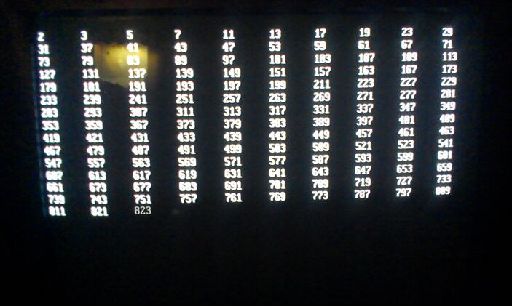](https://vignette.wikia.nocookie.net/uncovering-cicada/images/2/27/1357373692810.jpg/revision/latest?cb=20130105100510)

Screenshot from the video showing the prime number sequence being printed.

The image file was downloaded by multiple solvers and either burned to disc to run on a computer or opened in a virtual drive. Looking into its contents, we find three directories, "data", "boot" and "audio".

When booting from the image, a boot sequence appeared, printing a sequence of numbers to the screen. Investigating the sequence revealed that the live image prints out all prime numbers up to 3301. There were temporary two-second pauses at 1033 and 3301, where it stops at the latter and moves to the second stage.  The next, and last stage of the procedure is a screen that reads:

@1231507051321

The key is all around you.

Good luck.

3301

[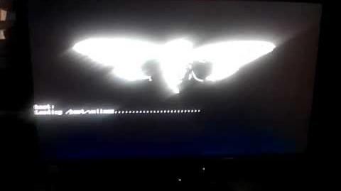](https://uncovering-cicada.fandom.com/wiki/File:Cicada_Boot_Sequence)

full

Further analysis of the live image turned up the [routine](https://uncovering-cicada.fandom.com/wiki/Bash_script_from_live_image) responsible for the display of the prime numbers. It is a linux shell script (found [here](http://pastebin.com/sSJgTKQD) , for those interested), which, luckily, is human-readable. It does not calculate prime numbers, like some suggested, but connected the printing command with a sleep command. In most cases, the sleep time is 0.5 seconds. In case of the primes 1033 and 3301 however, the sleep time is 2 seconds, which manifested the relevance of those two numbers. Also, this clue said "you" not "we", differing from the last one in the choice of words.

Also found in the image was [this](https://uncovering-cicada.fandom.com/wiki/PGP_Signature_from_live_cd) PGP signature, which has been verified to be 3301's official signature released during the puzzle in 2012.

It is possible to interrupt the boot sequence by pressing CTRL+C. User "tc" is active and does not require a password, is in sudoers file with no prompt. `sudo ash` to raise to root. Further inspection revealed nothing that is not listed in this wiki.

Another video of Cicada OS: <http://www.youtube.com/watch?v=PTFa6dwCEiA>

**The Music**

The folder "audio" contained an audio recording. The title of the recording was "761.mp3" and can be downloaded [here](https://anonfiles.com/file/b4a0a572aa4e307facb9e75e37a364b5). The ID3 tags show us that the title of the file is "The Instar Emergence" and the artist "3301". The used instrument is a guitar, with distorting effects on it. On the track, a reversed guitar is played and amplified throughout. The song has been deconstructed and checked for hidden reversed messages, but as of yet has turned up nothing out of the ordinary.

The song is in the key of D♭ minor with a custom guitar tuning of D♭-A♭-D♭-G♭-A♭-D♭

You can listen to the song here:

[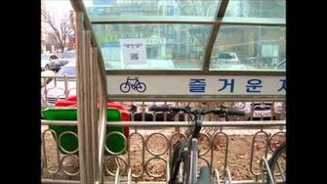](https://uncovering-cicada.fandom.com/wiki/File:Cicada_3301_Song_The_Instar_Emergence_(761))

The song found on the ISO

Key points about the track is the initial 'breath' sound, believed to be the sound of many cicadas and the tempo changes, beginning at approximately 135 bpm, accelerating to 145bpm, then slowing to 125bpm. This has led some to believe that the song has been slowed down by 5%. The only instruments  used were a guitar acoustic and electric and an effect driven bass drum.

[A draft spectral anlysis](http://www.anony.ws/i/2013/01/07/SE5OU.png) shows a constant hum at 15.4-16.1kHz, and empty notches under 500Hz starting from 1:56. A hexdump of the mp3 file revealed the following message:

The Instar Emergence

Parable 1,595,277,641

Like the instar, tunneling to the surface

We must shed our own circumferences;

Find the divinity within and emerge.

The original message had "\n" attached to the end of each line. This character sequence is used to indicate a new line in some programming languages. These were omitted due to the availability of proper formatting techniques.

The subgroup who were assigned the task of analyzing the poem/riddle above have speculated that circumferences might be a reference to perceived limitations rather than actual physical walls. "Find the divinity within and emerge" is most likely a reference to the divine ratio, or phi. Such shedding may also be a reference to the way Cicadas shed their shells.

It has also been pointed out that the song is 2:47 long, or 167 seconds, which is prime.  It is also a reversal of the name of the file: 761.mp3, and 761 is also prime.

[Meaning of Parable 1.595.277.641](https://uncovering-cicada.fandom.com/wiki/Instar_emergence_(mp3_and_hidden_poem)#Meaning_of_Parable_1.2C595.2C277.2C641)

**The Twitter**

While people still searched through the image to find more hints that may have been overlooked, somebody in the IRC found a [twitter account](https://twitter.com/1231507051321) which got our attention, to say the least. Multiple things were strange about that twitter. It fits the overall "style" of cicada, it was registered shortly after the first downloads of the live image and it had no followers. It was later found to be the reference on the boot CD to @1231507051321 (note: 1231507051321 is a palindromic prime number). The most striking thing about it though was the messages it tweeted.

Each tweet consisted of an offset, and 65 bytes of hex code. For example, the first message went like so:

0000000: b69ccce300104a464802545959580001008d0000ff8b6131616a6a632737293d3e322b3b3e3f263a203c0c4762677c326767713d73716d697b6e3000505b494e47

3301 appears to have used a bot to post the tweets at 5 minute intervals (up until 0:00 GMT Jan 7), then onto four minute intervals until 19:00 GMT Jan 7, where it was seemingly random up until 22:04 GMT Jan 7, where it moved onto two minute intervals. The twitter bot stopped posting tweets at 4:52 GMT on Jan 8.

The meaning of the tweets and the rest of the files left the solvers stumped for several hours. A full feed of the tweets is avaliable [here](https://uncovering-cicada.fandom.com/wiki/All_cicada_3301_twitter_feeds).

**The Gematria**

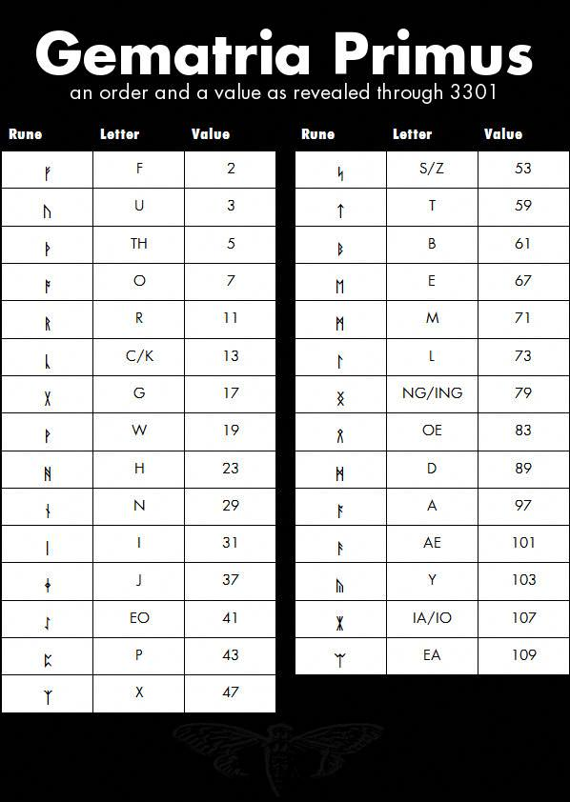Result of xor-ing the twitter information with 761.mp3

After a day of fruitless searching, an IRC user did the impossible and solved the next puzzle. This user took the 761.mp3 file, and [XORed](https://uncovering-cicada.fandom.com/wiki/XOR) it with the file produced by following the instructions in the twitter. The result was a .jpg file. It was possible to "pre"-construct the image resulting from the tweets.

The .jpg file appears to be a rune table, consisting of three columns, named "Rune", "Letter" and "Value", and 29 entries. "Rune" contains the actual rune character, "Letter" contains one or more plain text characters and "Value" contains a number. It is interesting to note that the numbers to be found in "Value" are all ascending primes, building the sequences of the first 29 prime numbers. As a member in the IRC pointed out, the runes stem from the [Anglo-Saxon rune set](http://en.wikipedia.org/wiki/Anglo-Saxon_runes), and the letters are in the order of the Anglo-Saxon runes. It was revealed that this is a fully-blown Gematria, which can be applied to different pieces of text to reveal interesting numbers. 'The Instar Emergence', for example, produces 761, which is the name of the file and the file's time signature reversed.

It was soon discovered that this image, like the very first one, contained a hidden message, once again masked via OutGuess. The message itself can be found [here](https://uncovering-cicada.fandom.com/wiki/OutGuessed_message_from_rune_table). As in every message from Cicada, the content was followed by a PGP signature, which proved the authenticity of the message

|  |
| --- |
| **[**[**Collapse**](https://uncovering-cicada.fandom.com/wiki/What_Happened_Part_1_(2013))**]**[**PGP**](https://uncovering-cicada.fandom.com/wiki/PGP_TUTORIAL)**-Signed Message** |
| -----BEGIN PGP SIGNED MESSAGE-----  Hash: SHA1          -----BEGIN PGP SIGNATURE-----  Version: GnuPG v1.4.11 (GNU/Linux)  iQIcBAEBAgAGBQJQ5lDTAAoJEBgfAeV6NQkP7nMQAJVg7DQiIA7NpkacR0RA4eBs  NZHJBQNHO2P22h+aFfP/rI1gjGaV3hMWaa2sQ4Vbi/W8eZuH40AsmZUy3EOb+4j0  3cJRJgAJI99ZjDcVXITm5VyUv+WIqCzBr+bHMK7pkMYQ/rEzeWD56tlsrDgFdjmh  PA/b7XrDcofd9JfBNFI7D/sF84HL2ig5baNo+MGjYl4Dq2cHX+SAafXmlN9PXFjx  HRBbuoMLlviKywQ8MnePBPYG6V8sIMmrJlHS5ZcNEaSJ9nGL4X0XbECqV79ermye  1EeNKcckoeeZMU86SabfMeyZozG04Vkbemn8JH5cssbuF8hf4fdN/LSP4NG0r5y9  jfRv7z59pL577ZpGAju5zBtlCBUvmxxNYR5IGLg+Fi/ICqcRC98mzesFnQ7wbDLS  HKyV95SBQK82bbqSREBfIrrNb+MjVtJwIvOY5OPTBViHPqrIuMw8KDGfSvw9ncCt  dase7vUjXxIrn36xDSRN6cMzTmFZ9lkQYkRAYq5ApERud+JfKCwszG/UxRwo1WOU  0ALaWXq5VMp+w5pvQkqg9eHpOriG9Z11VLdb53eTmxKrwyX/2eaiybsnMrRNuxv1  iE8PVRkifCcJccw1bGq8TyCQF3a5ozeiBRngAUT7BwZhLa4bShtki7amR0ZZgbKk  8JRMGvoSA5NNTEwvUhwl  =ZeNf  -----END PGP SIGNATURE----- |
| [Check Signature](https://isitcicada.challenge.pt/l?link=https://pastebin.com/CF394kLD) |

**The Onion, part 1 of 2**

After finally getting a message from 3301, the solvers found that it was, to quote the IRC, 'Mostly Blank'. The message, it turned out, contained a mixture of tabs and spaces. The solvers converted this to binary, then again to ASCII, then they found the next message:

"Come to emiwp4muu2ktwknf.onion"

"We shall await you there."

"Good luck."

"3301"

A quick filler: emiwp4muu2ktwknf.onion is a website that can only be accessed through Tor, which is using a hidden service URL, similar to the last Cicada puzzle.

Upon visiting the website, the solvers were presented with the following message:

Note: the formatting may be a little off on your screen. Press control/command and - to view the full message.

Web browsers are useless here.

,+++77777++=:, += ,,++=7++=,,

7~?7 +7I77 :,I777 I 77 7+77 7: ,?777777??~,=+=~I7?,=77 I

=7I7I~7 ,77: ++:~+7 77=7777 7 +77=7 =7I7 ,I777= 77,:~7 +?7, ~7 ~ 777?

77+7I 777~,,=7~ ,::7=7: 7 77 77: 7 7 +77,7 I777~+777I= =:,77,77 77 7,777,

= 7  ?7 , 7~,~ + 77 ?: :?777 +~77 77? I7777I7I7 777+77 =:, ?7 +7 777?

77 ~I == ~77= +777 777~: I,+77? 7 7:?7? ?7 7 7 77 ~I 7I,,?7 I77~

I 7=77~+77+?=:I+~77? , I 7? 77 7 777~ +7 I+?7 +7~?777,77I

=77 77= +7 7777 ,7 7?7:,??7 +7 7 77??+ 7777,

=I, I 7+:77? +7I7?7777 :  :7 7

7I7I?77 ~ +7:77, ~ +7,::7 7

,7~77?7? ?: 7+:77777, 77 :7777=

 ?77 +I7+,7 7~ 7,+7 ,?  ?7?~?777:

I777=7777 ~ 77 : 77 =7+, I77 777

+ ~? , + 7 ,, ~I, = ? ,

77:I+

,7

 :77

 :

Welcome.

**Establishing a connection**

The solvers soon found that web browsers were indeed useless, and that we would have to telnet into the website through the tor network. Some solvers did so, and they found that the website included an interactive shell. They could type in any number to have it factorized, 'count' to have it count up prime numbers, 'quit' to quit, and 'hello' to return a message. Please see [here](https://uncovering-cicada.fandom.com/wiki/2013_offset_messsage_from_telnet) for the original message.

It was soon discovered that the messages could be turned into ASCII which created another message, again GPG signed by 3301. The message reads as follows:

Very good.

You have done well to come this far.

xsxnaksict6egxkq.onion

Good luck.

3301

This led us to another, the second .onion address.

**The Clues**

As the solvers patiently waited for more news about the second .onion, they continued to explore other options that they may have overlooked in the blind rush towards victory.

A new message was found by telnetting "hint" or "clue". And XORing result with _560.00 file from the DATA folder on 3301.txt CD image.

You can't see the forest when you're looking at the trees.

Good luck.

3301

Full Message:  
<https://pastee.org/2zae9>  
"hint" output:  
<https://pastee.org/tjdbs>

**THE DIFFERENCE**

In Cicada OS the solvers found two files named Wisdom and Folly in ./tmp

<http://codeseekah.com/cicada/folly>

<http://codeseekah.com/cicada/wisdom>  
Wisdom is exactly the same as folly, but appears to represent no file type.

**THE PRIMES**

Telnetting 'primes' into the shell printed out a list of primes similar to the one on Cicada OS, but some primes were missing and two have extra spaces in front of them.

There were extra spaces between 29-31 and 3257-3259  
And some missing primes between 71-1229

The missing primes are as follows:

73 79 83 89 97 101 103 107 109 113

127 131 137 139 149 151 157 163 167 173

179 181 191 193 197 199 211 223 227 229

233 239 241 251 257 263 269 271 277 281

283 293 307 311 313 317 331 337 347 349

353 359 367 373 379 383 389 397 401 409

419 421 431 433 439 443 449 457 461 463

467 479 487 491 499 503 509 521 523 541

547 557 563 569 571 577 587 593 599 601

607 613 617 619 631 641 643 647 653 659

661 673 677 683 691 701 709 719 727 733

739 743 751 757 761 769 773 787 797 809

811 821 823 827 829 839 853 857 859 863

877 881 883 887 907 911 919 929 937 941

947 953 967 971 977 983 991 997 1009 1013

1019 1021 1031 1033 1039 1049 1051 1061 1063 1069

1087 1091 1093 1097 1103 1109 1117 1123 1129 1151

1153 1163 1171 1181 1187 1193 1201 1213 1217 1223

You can use a hosted telnet service to access the tor website [here](http://codeseekah.com/cicada/console.html).

**The Onion, Part 2 of 2**

Once the solvers had found the second .onion, the next logical step was to visit it with a browser. Upon arrival, they found the following:

Patience is a virtue.

Rummaging through the source code for the html, they found the following:

<html>

<head><title>3301</title></head>

<body>

Patience is a virtue.

<!-- which means, come back soon. -->

</body>

</html>

Soon afterwards, someone attempted to telnet into it, producing an error message which contained the address of the VPS on which the site was hosted. Promptly afterwards, the site was taken down.

After this the 2nd Onion site finally reopened. The solvers got the following hint:

You already have everything you need to continue.

Sometimes one must "knock on the sky and listen to the sound."

Good luck.

This hint told the solvers that they needed to ping the website's IP address and listen to the reply. Each ping reply was laced with data bytes, which could be combined to make the following:

|  |
| --- |
| **[**[**Collapse**](https://uncovering-cicada.fandom.com/wiki/What_Happened_Part_1_(2013))**]**[**PGP**](https://uncovering-cicada.fandom.com/wiki/PGP_TUTORIAL)**-Signed Message** |
| -----BEGIN PGP SIGNED MESSAGE-----  Hash: SHA1  Well done. You have come far.  pklmx2eeh6fjt7zf.onion  Good luck.  3301  -----BEGIN PGP SIGNATURE-----  Version: GnuPG v1.4.11 (GNU/Linux)  iQIcBAEBAgAGBQJQ7vVDAAoJEBgfAeV6NQkP9x4P/31A5LPzIhkii8sBjuVxIcOn  4KFQO+uVVsR53zImSqlhq6iVAE9+Ko7vIqjD2whTIUFVYZNBq/92wEZJuCSonovH  HqYZTQihIS9d+QDuwUNvXr4ilrRmITKMrWw3D23rpWs6ZlnehuUDVI8unbN9Zi3h  3hvok3/+/FofLia9Kvbo+FIDi7T9NNRpqepgXd/6dQIP4kn63kKCP20QMdRf2fXF  ZLx5ADS14OvaNFNUAHTJ1qdkPYcdTiNDJkxqk1s82y2doGoEP0ChBUJxlyMiUVXn  1iLOwm2KNrf6If64KxEoetOraWqg9P6l3BjGVPCkrotB608SSs2Lihsa4B0ifI33  ABlpvSDIgpBu/zIO/WFYOfnnrtdvDpVP/Wy+pgqZJ/wOUuhJZhzi5vppjVCm/q9H  C/aXQxa+XXe7his4f9tuIBD1wIYAtnE8M0uDCsfiZjBaZNMnOO7/hOwnNQSBAMcr  KqL5yHSnpI50CtoA+6ycWZURBkrt1rt4eNxsCqQ1XWed/hWbqb6SlJJemJOPbbmt  V5D7iDUO+r2OIUEZTfCSjdzrXcJ8FLtqCGVaLJhCdsyirRHmURwkYLw/B8TpcJQz  qbY6oeDxDosIbE6uhDNV2RVKmpWqLDMhLGHVjkDjJpodE5L3ObbylWuRnHfFqfKH  1mubvMAGo03rxxlY+9XG  =6Sgs  -----END PGP SIGNATURE----- |
| [Check Signature](https://isitcicada.challenge.pt/l?link=https://pastebin.com/4nQNexmc) |

**The Third Onion**

On the third Onion page the solvers recieved a message instructing them to 'standby for coordinates'. They prepared to visit the addresses which these would undoubtedly lead them to.

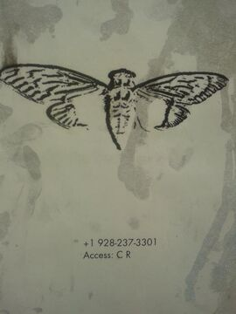Each poster had a phone number on it as well as an access code. Note that each phone number either ends in 3301 or 1033.

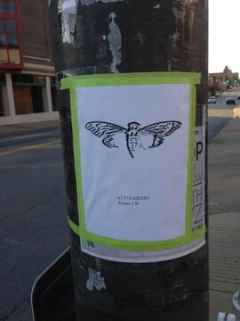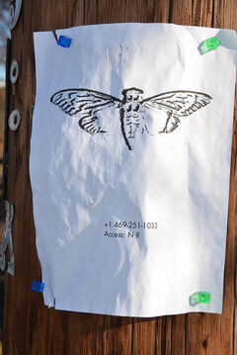

Calling the phone number gave an automated speech asking for a code to be typed into the dialer. Solvers soon realised that they had to convert the access code given in the poster to it's gematrified format and type that in. Upon doing so the following message was given (it varied depending on location, this one was for Portland):

Dataset:13

Offset:12821

Data:28C07E1B102D4D5C4C1A376E064477E1416FCC94928765

The data, when XORed with the 560.13 (the 13 coming from the dataset) file from DATA, provided the user with a string of text, notably in this case "gbyh7znm6c7ezsmr.onion". It's important to note that each location gave a different onion address.

All in all, 6 of the locations had their codes recovered, while the seventh was not physically visited, but the phone number obtained by wardialing all numbers ending in 1033.

On each of these onion addresses (as listed in the table below), each solver was given an SSSS code, which stands for [Shamir's Secret Sharing Scheme](https://uncovering-cicada.fandom.com/wiki/Shamir%27s_Secret_Sharing_Scheme). A secret sharing scheme allows someone to share a secret with a certain number of people, who each get their own string. Once enough of these secrets come together, they can be combined to create the final secret. Each location, its SSSS code and some other data on each part is in the below table:

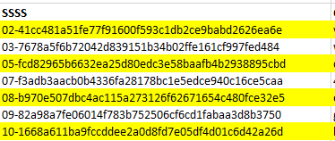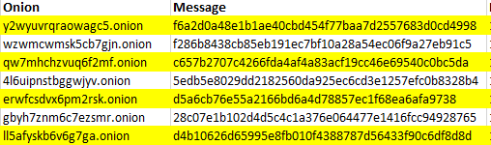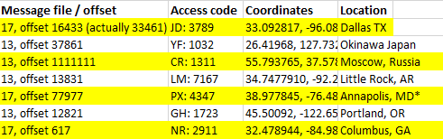

Once 5 of 10 SSSS codes had been retrieved, they could be [decrypted](http://point-at-infinity.org/ssss/demo.html) to form their message, which was:

p7amjopgric7dfdi.onion

This was the fifth onion.

Here is how test looked: <http://imgur.com/a/YFA1a>

Here ends Part 1 of What Happened during the 2013 Cicada puzzle, and also ends the part of the 2013 puzzle that was fully publicly available. Part 2 is available [here](https://uncovering-cicada.fandom.com/wiki/What_Happened_Part_2_(2013)), and relies entirely on leaks (which may also comprise integrity).